Math 6 - W1

A Basic Introduction to Number Theory and Classification

Categories of Numbers
-Real Numbers: All numbers that are not imaginary. While this sounds stupid, there are such things as imaginary numbers, but you don’t have to worry about that until like Algebra 2. Or Precalculus. So for now, just think of it as all the numbers in the whole wide world.
-Whole Numbers: These are, well, all the whole numbers. So … 0, 1, 2, 3, 4, 5, etc.
-Natural (Counting) Numbers: These are almost like the whole numbers, except without the zero. So … 1, 2, 3, 4, 5, 6, etc.
-Integers: Kind of like the whole numbers, but also the negative ones as well. What I mean by that is … -2, -1, 0, 1, 2, etc.

Properties of Numbers
-Even Numbers: Pretty much any nonzero integer that can be divisible by two.
-Odd Numbers: Pretty much any nonzero integer that cannot be divisible by two.
-Prime Numbers: Any integer whose only factors are 1 and itself.
-Composite Numbers: Any integer that has more factors than just 1 and itself.

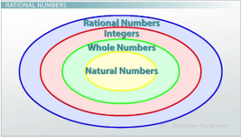
While this lesson may seem fairly easy, please keep in mind that all of math builds off of each other. For all intents and purposes, this is a vocabulary lesson to help you become more familiar with the verbiage that we use in math.

